H.T No
Regulations:
A20

Sreenidhi Institute of Science and Technology
(An Autonomous Institution)
Code No: 8BC02 Date: 03-Nov-2021 (FN)

B.Tech I-Year I- Semester External Examination, Oct/Nov-2021 (Supplementary)
ENGINEERING GRAPHICS (EEE, ME, IT and ECM)

Time: 3 Hours Max.Marks:70

Note: a) No additional answer sheets will be provided.
b) All sub-parts of a question must be answered at one place only, otherwise it will not be valued.
c) Missing data can be assumed suitably.

ANSWER ANY 5 OUT OF 8 QUESTIONS. EACH QUESTION CARRIES 14 MARKS.

Bloom's Cognitive Levels of Learning (BCLL)

Remember | L1 | Apply | L3 | Evaluate | L5
Understand | L2 | Analyze | L4 | Create | L6

 |  |  | BCLL | CO(s) | Marks
1. | a) | A Circle of 60mm diameter, rolls along a line for one revolution clock wise direction. Draw the locus of a point on the circle, which is contact with the line and draw a normal to the curve at a point 45mm from the directing line. | L4 | CO1 | [7M]
 | b) | Construct the rectangular hyperbola passing through the point P with coordinates 20mm and 35mm. | L3 | CO1 | [7M]
2. | a) | Draw the projections of the following points, keeping the distance between the projectors as 25mm on the same reference line.  i).Point A 35mm above H.P and 50mm infront of V.P  ii)Point B 40mm above H.P and 50mm behind V.P | L3 | CO2 | [7M]
 | b) | A Point A is 20mm above H.P and 25mm in front of V.P. Another point B is 25mm behind V.P and 45mm below H.P. Draw the projections of A and B, keeping the distance between the projectors equal to 80mm,join its top views and front views. | L3 | CO2 | [7M]
3. | a) | A line AB of 70mm length, is inclined at an angle 30° to H.P and 45° to V.P. The point A is 20mm above H.P and 25mm infront V.P. draw the projections of the line | L3 | CO3 | [7M]
 | b) | A line PQ 60mm long is parallel to VP and inclined at an angle of 30º to HP. The lower end P is 20mm above HP and 25mm in front of VP. Draw the projections of the line. | L3 | CO3 | [7M]
4. | a) | A square plane ABCD of side 50mm is parallel to H.P and 25mm away from it .Draw the projections of the plane ,when two of its sides are parallel to V.P and inclined at 30° to V.P. | L3 | CO4 | [7M]
 | b) | A regular pentagonal plane of side 30mm is placed with one of its side on HP, the surface is inclined at 45º to HP and perpendicular to VP. Draw its projections. | L3 | CO4 | [7M]
5. |  | Draw the orthographic view of below figure  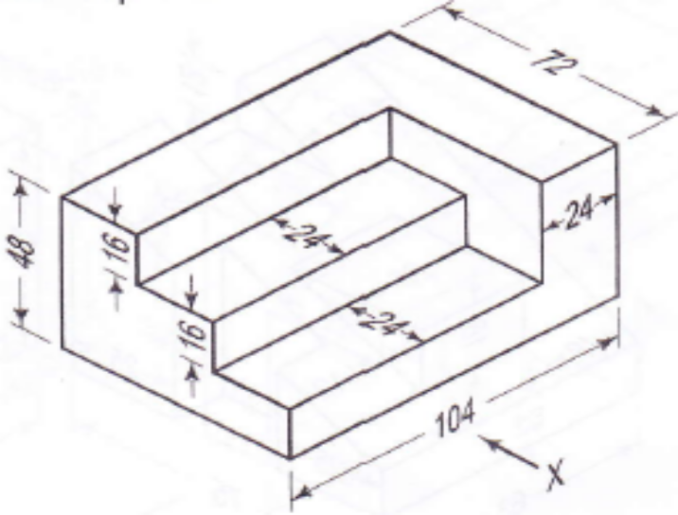 | L5 | CO5 | [14M]
6. | a) | Define CAD. Explain its advantages, disadvantages and applications. | L3 | CO6 | [7M]
 | b) | Differentiate between 2D and 3D. | L2 | CO6 | [7M]
7. | a) | Construct a parabola, when the distance between focus and the directrix is 50mm.Draw the tangent and normal at any point P on the curve | L3 | CO1 | [5M]
 | b) | A cylinder of diameter of base 35mm and axis 70mm long ,is resting on its base on H.P .It is cut by a section plane ,perpendicular to V.P. and inclined at 45° to H.P . The section plane is passing through the top end of an extreme generator of the cylinder. Draw the development of the lateral surface of the cut cylinder. | L4 | CO2 | [5M]
 | c) | A line AB 30mm long is perpendicular to VP and parallel to HP. Its end A is 10mm in front of VP and the line is 20mm above HP. Draw the projections of line. | L4 | CO3 | [4M]
8. | a) | Draw the projections of a cylinder of 40mm diameter and axis 65mm long ,when it is lying on H.P, with its axis inclined at 45° to H.P and parallel to V.P. | L4 | CO4 | [5M]
 | b) | A square prism its base side 35mm and axis height 65mm perpendicular to HP, resting with its base on HP, such that one of its face 10mm in front of VP and perpendicular to VP. Draw its projections. | L5 | CO5 | [5M]
 | c) | List out editing commands, drawing commands. | L2 | CO6 | [4M]

-- 00 -- 00 –

